Student Performance Prediction System

Project Id: 27

Name : Nidhi Bhatt
Class Roll Number: 57
University Roll Number : 2028781
Section and Group: K G2

Name : Devashish Chauhan
Class Roll Number: 46
University Roll Number : 2028705
Section and Group: K G2

- Problem Description 3
- Architecture 4
- Models model 5
- Evaluation metrics used 6
- Preliminary Results and Visualizations 7
- References 8

1. Problem Description
Student performance is influenced by many different factors such as study habits, attendance, family background, access to resources, and overall learning environment. However, it is often difficult to understand how these factors collectively impact a student’s final exam score.The main problem addressed in this project is to analyze these factors and build a system that can predict student academic performance based on available data. In addition to predicting exam scores, the system also aims to identify whether a student is likely to pass or fail and determine their level of academic risk.By using machine learning techniques, the goal is to move beyond simple assumptions (such as “more study hours means better results”) and instead uncover meaningful patterns in the data. This can help in identifying students who may need additional support at an early stage.Overall, the project focuses on developing a data-driven approach to better understand student performance and assist in making informed decisions for academic improvement.

- Architecture

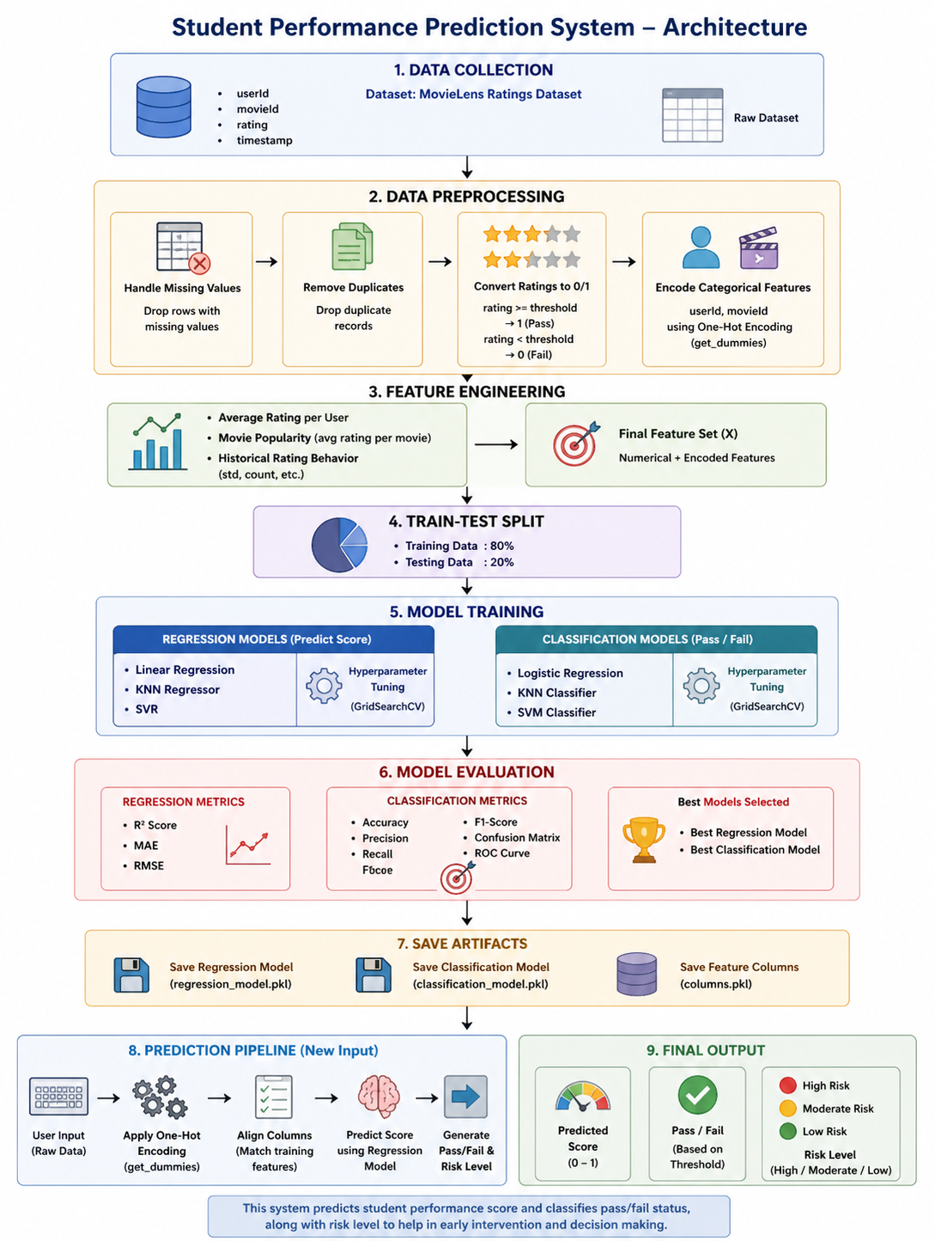

Student Performance System

- Models Used(Applied/ Planned) Give a brief introduction of the models used

- Linear Regression

Linear Regression is one of the simplest and most commonly used machine learning algorithms for predicting continuous values. It works by establishing a linear relationship between the input features and the target variable.
In this project, Linear Regression was used to predict students’ exam scores based on factors such as study hours, attendance, and other relevant features. It was chosen because it is easy to understand, quick to train, and often performs well when the relationship between variables is reasonably linear. It also served as a strong baseline model to compare with more complex approaches.

- K-Nearest Neighbors (KNN Regressor)

KNN is a distance-based algorithm that makes predictions by looking at the closest data points (neighbors) in the dataset. Instead of learning a formula, it simply finds similar cases and uses them to estimate the output.
In this project, KNN was used to predict exam scores by identifying students with similar characteristics. The idea was that students with similar study patterns and conditions would likely have similar performance.
However, it was observed that KNN did not perform as well as the other models. This is mainly because it is sensitive to noise and struggles when there are many features, making distance calculations less reliable.

- Support Vector Regression (SVR)

Support Vector Regression is a more advanced model that can handle both linear and non-linear relationships. Instead of trying to perfectly fit all data points, it focuses on fitting them within a certain acceptable error range, which makes it more robust.
In this project, SVR was used to capture more complex relationships between input features and exam scores. It performed comparably to Linear Regression, showing that the data had some level of structure that both linear and slightly non-linear models could capture effectively.

- Logistic Regression (Classification Model)

Logistic Regression is used for classification tasks, where the goal is to assign data into categories. In this case, it was used to classify students into Pass or Fail.
The classification was based on a threshold applied to exam scores. Logistic Regression was selected because it is simple, efficient, and provides probability-based outputs, which are useful for evaluation using metrics like accuracy, precision, recall, and ROC-AUC.

- Evaluation metrics used

For Regression Models

The following metrics were used to evaluate how accurately the models predicted exam scores:

R² Score (Coefficient of Determination)

R² measures how well the model explains the variability in the target variable. In simple terms, it shows how much of the variation in exam scores can be explained by the input features.
A value closer to 1 indicates a better fit.
A value near 0 means the model does not explain the data well.
This metric was useful for comparing overall model performance.

2. Mean Absolute Error (MAE)

MAE calculates the average absolute difference between the actual and predicted values.
It gives a clear idea of how far the predictions are from the actual scores on average.
Since it uses absolute values, it is easy to interpret and less affected by extreme errors.

3. Root Mean Squared Error (RMSE)

RMSE measures the square root of the average squared differences between
predicted and actual values.
It penalizes larger errors more heavily than MAE.
This makes it useful for identifying models that produce large prediction mistakes.

For Classification Model

The following metrics were used to evaluate the performance of the pass/fail classification:

1. Accuracy

Accuracy represents the proportion of correctly predicted instances out of the total predictions.
It gives a general idea of model performance.
However, it may not be reliable if the data is imbalanced.

2. Precision

Precision measures how many of the predicted “Pass” cases were actually correct.
It focuses on reducing false positives.

3. Recall

Recall measures how many of the actual “Pass” cases were correctly identified.
It focuses on reducing false negatives.
In this project, this is important because missing a failing student can be critical.

4. F1-Score

F1-score is the harmonic mean of precision and recall.
It provides a balanced measure when both false positives and false negatives matter.

5 Confusion Matrix

A confusion matrix provides a detailed breakdown of predictions:
True Positives (correctly predicted pass)
True Negatives (correctly predicted fail)
False Positives (predicted pass but actually fail)
False Negatives (predicted fail but actually pass)
This helps in understanding the types of errors the model makes.

6 ROC Curve and AUC Score

The ROC curve shows the trade-off between true positive rate and false positive rate different thresholds.
The AUC (Area Under Curve) value summarizes this performance.
A higher AUC indicates better classification capability.

5. Preliminary Results and Visualizations

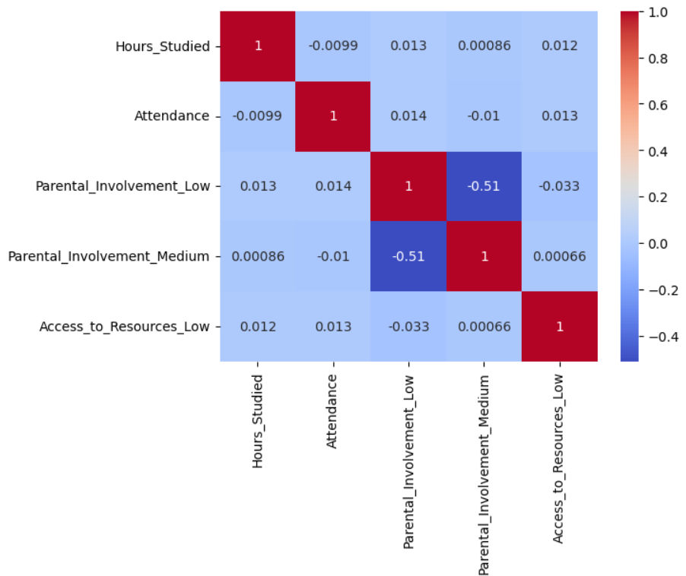

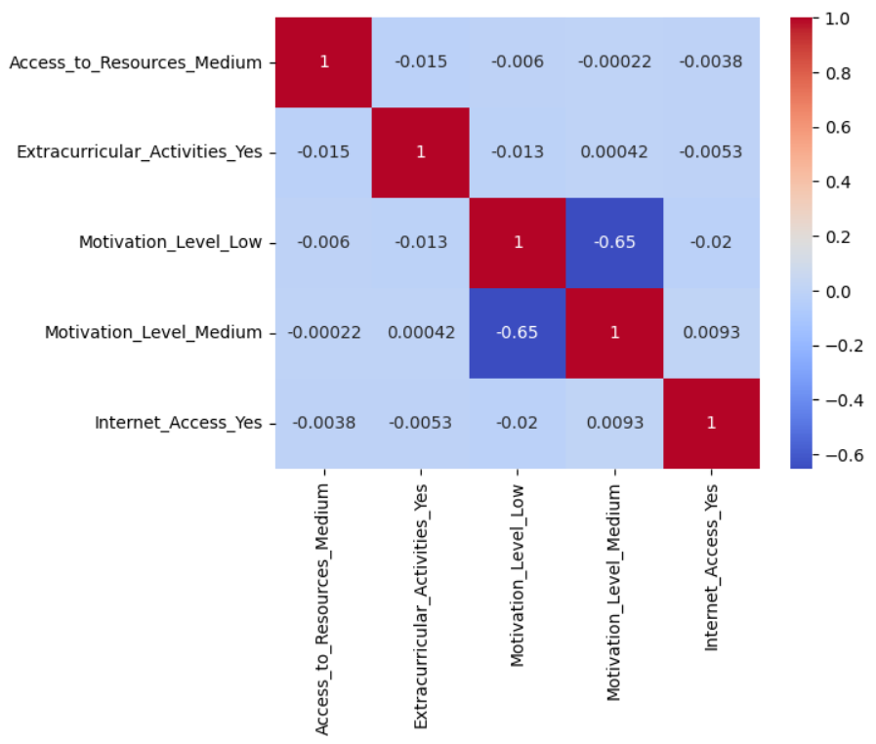

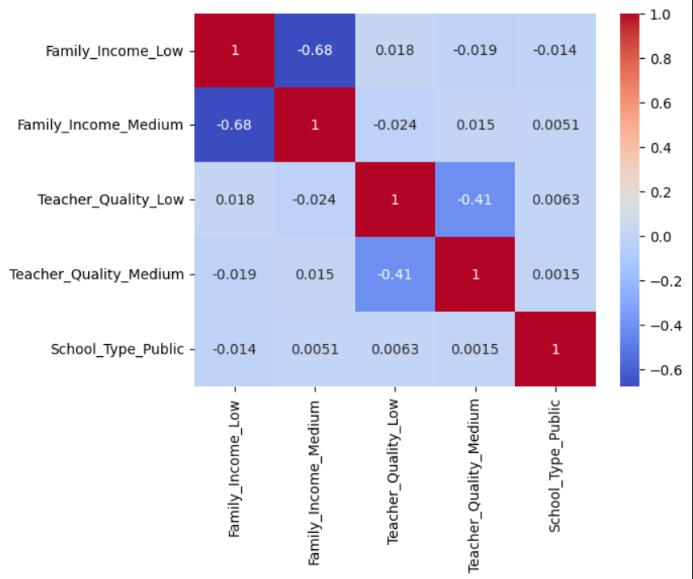

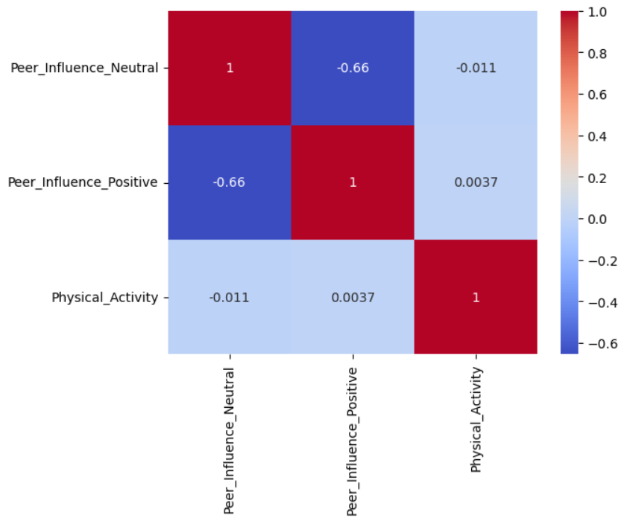

Heatmap showing correlation between all features

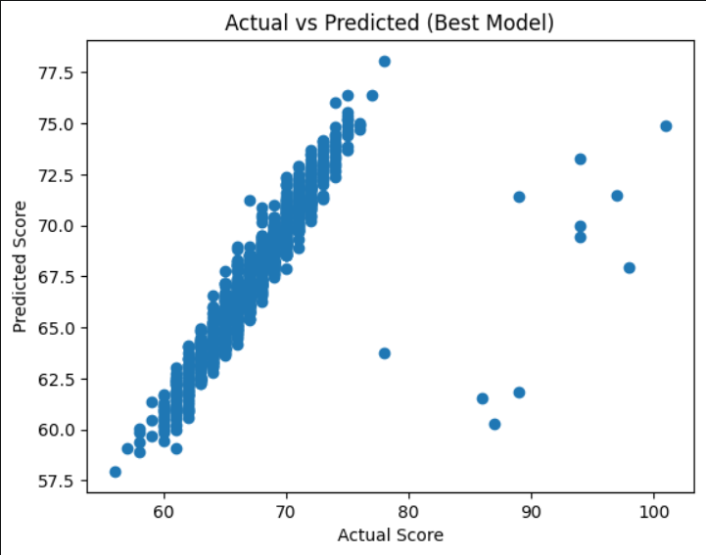
Actual vs Predicted Plot

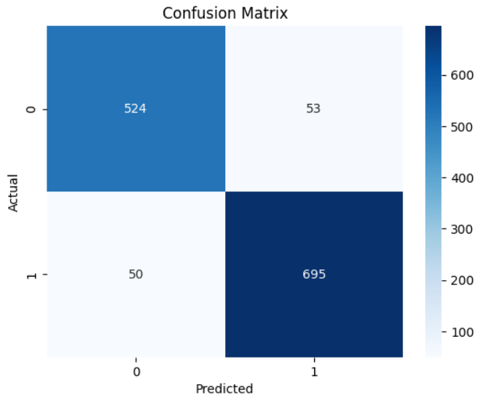

Confusion Matrix

6. References:

- Hands-On Machine Learning with Scikit-Learn, Keras, and TensorFlow
- Introduction to Machine Learning with Python
- Scikit-learn Documentation: https://scikit-learn.org/stable/
- Pandas Documentation: https://pandas.pydata.org/docs/
- NumPy Documentation: https://numpy.org/doc/
- Matplotlib Documentation: https://matplotlib.org/stable/
- Seaborn Documentation: https://seaborn.pydata.org/
- Kaggle (for datasets and inspiration): https://www.kaggle.com/
- Machine Learning concepts from standard academic materials and online tutorials

